Lab

Java basics – Getting started



Lab: Introduction to Java and Eclipse

Objective
In this lab, you will:
- create a Console program using the Eclipse IDE.
- run the program.

Overview
Eclipse is the development tool used by many Java developers and throughout this course. This lab will show you how to create and run a Java program.

Step-by-step

Creating a new Java application
- Launch Eclipse and type C:\Labs as the location for your ‘workspace’. (You may choose a different location but make a note of where it is.)
- Dismiss the Welcome window if it appears.
- Choose menu option File > New > Java Project.
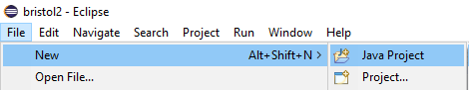
- Type the following project name. If the default location is the one you want to use, leave it as it is; otherwise, uncheck ‘Use default location’ and enter your choice of folder. Accept the other default settings:
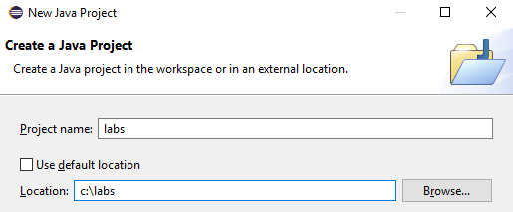
- Select ‘Finish’.
- Right Select on the labs > src node and select New > class.
- Type lab1 as package name and select public static_void main(String[] args).
Select ‘Finish’. (This step will be left out from now on.)

Writing the code
- In the Program class's main method, type the following:
package lab1;

public class Program {
public static void main(String[] args) {
System.out.println("Hello, world!");
}
}
Tip: Type syso followed by Ctrl-Space to type System.out.println
Make sure you make full use of this time saving editor command.

Building and running the program
- Compiling the program is done by saving your code (Ctrl-s).
- Press Ctrl+F11 to run the program or select the green Run icon.
A Console window will become active at the bottom of Eclipse.
Please view the output for the println messages.

Building and running the program using command line

From Development → Staging → Production
In this part you will deploy a simple Java app but the procedure is the same for a larger apps. Let’s define a few terms:
- Development: Where you write and test code on your own machine
- Staging: A "dress rehearsal" environment that mimics production. You deploy here first.
- Production: The live environment users interact with.

Write a simple app (file: HelloWorld.java)

public class HelloWorld {
public static void main(String[] args) {
System.out.println("Hello, World!");
}
}

Compile → javac HelloWorld.java

Package into a JAR → java -cfe HelloWorld.jar HelloWorld HelloWorld.class

Run the code → java -jar HelloWorld.jar

Store your files in Github

Objectives:
In this section, you will store all your files using Git commands and use the same method to push your files to a cloud repository on GitHub.
- Install Git on your PC if you’ve not installed it already.
Please select the links below for Mac or windows PCs.
(Alternatively, use QA’s provided Virtual PCs.)
https://git-scm.com/download/mac
https://git-scm.com/download/win
- Create a free GitHub account using https://github.com/ if you don’t have one.



- Create a public new repository called mod1-labs (or any name you prefer).

- Select Create repository.
- Copy the address of your repository.
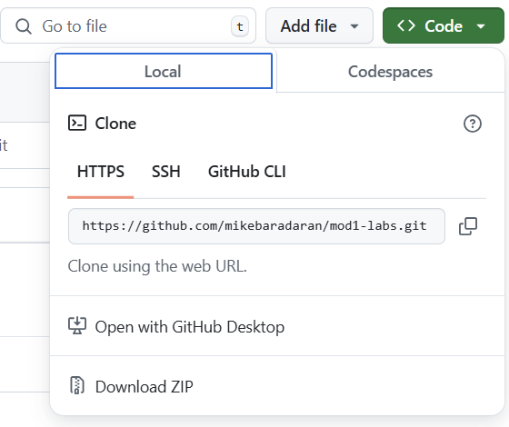
- Start a new Terminal session and navigate to the \labs folder.
cd \labs
git add .
git commit -m "first commit"
git branch -M Main
git remote add origin https://github.com/YourUsername/YourRepo.git
git push -u origin Main
- To save all the files in the \labs folder each time you complete a lab, type these commands.
Open a Terminal session in \labs folder
git add .
git commit -m "lab xx completed"
git push
- Now, refresh your browser to view your lab files on GitHub.

** End **



